>1

>tree – displays files and directories in tree structure.

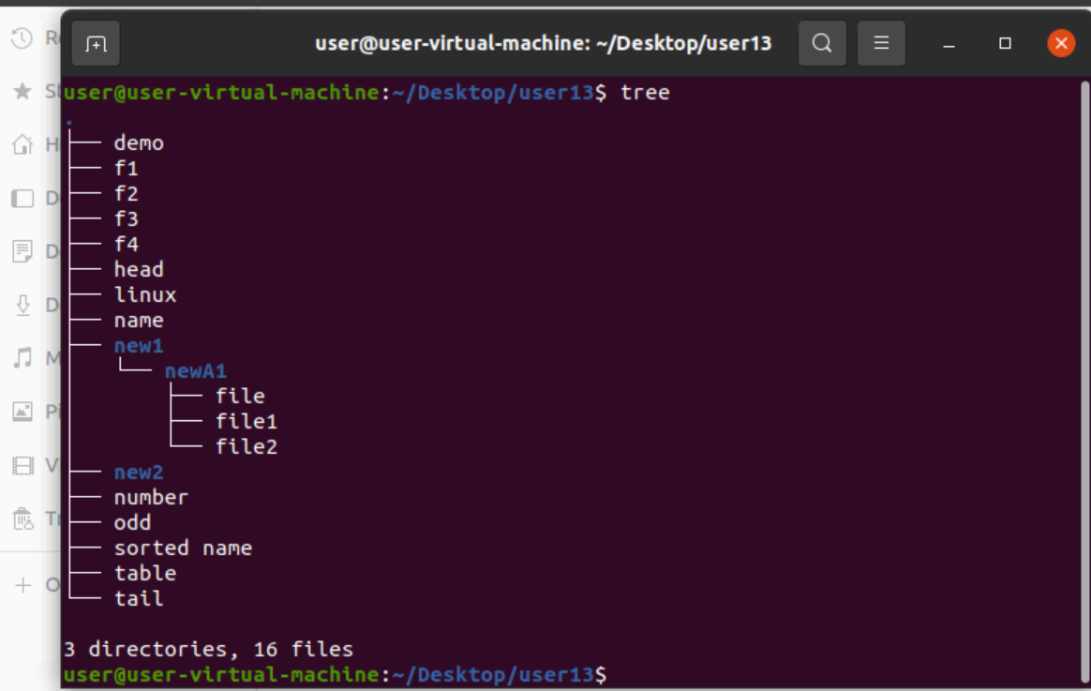

>2

>grep ‘ ‘ – display specific characters.

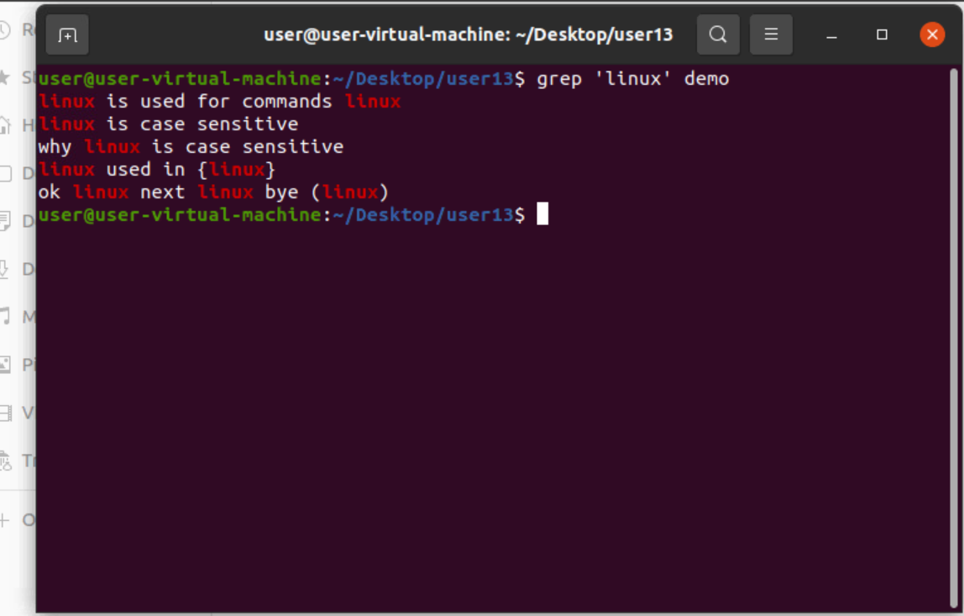

>3

>more fname – displays data over the terminal.

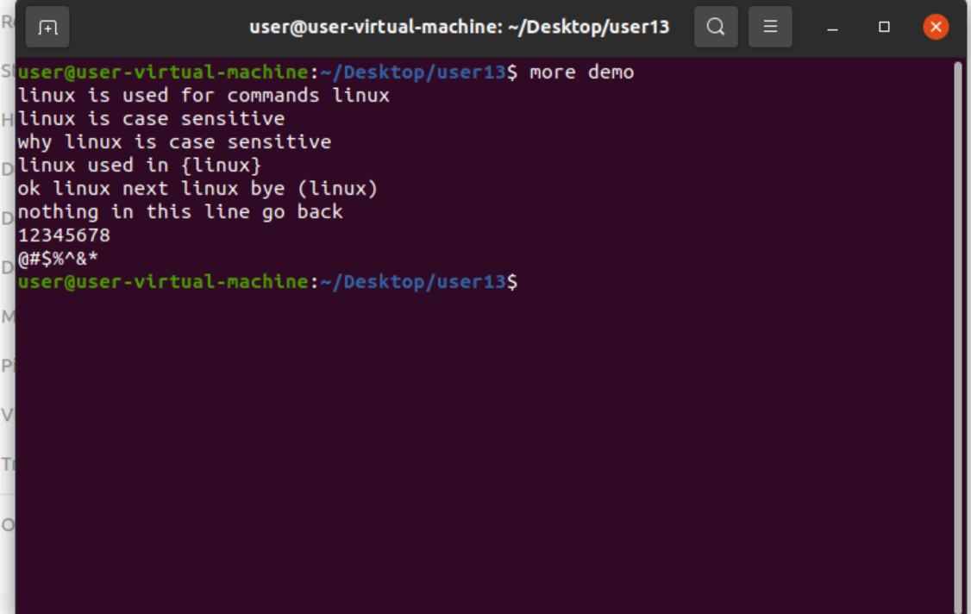

>4

>grep -i – display non case sensitive characters.

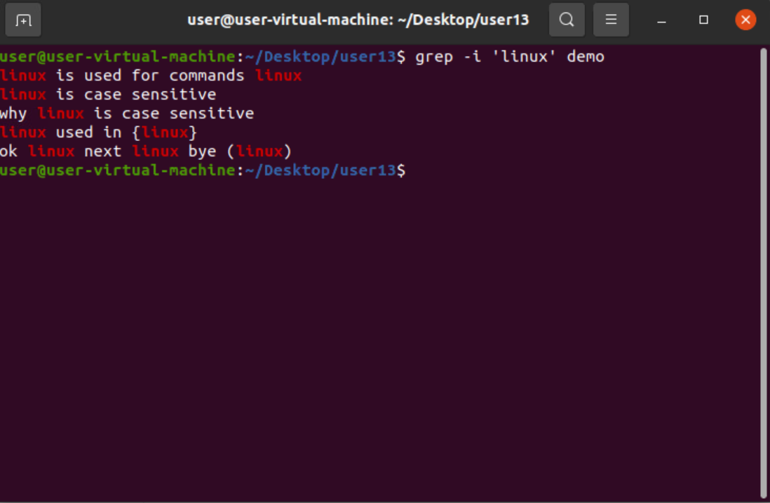

>5

>grep -i ‘ ‘ f1 f2.. – display multiple files.

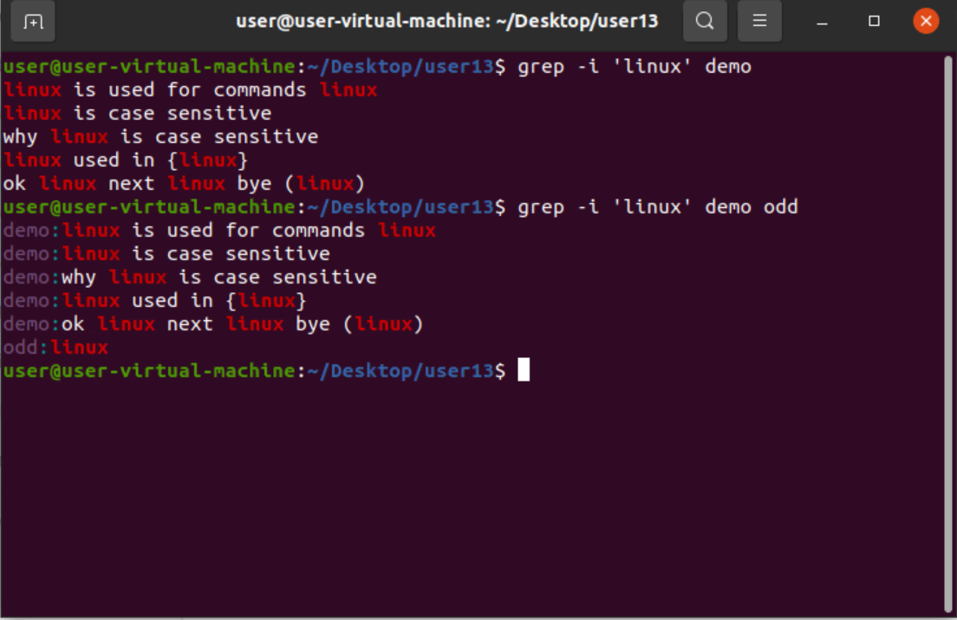

>6

>grep -i ‘ ‘ \* - displays all specific characters in all files.

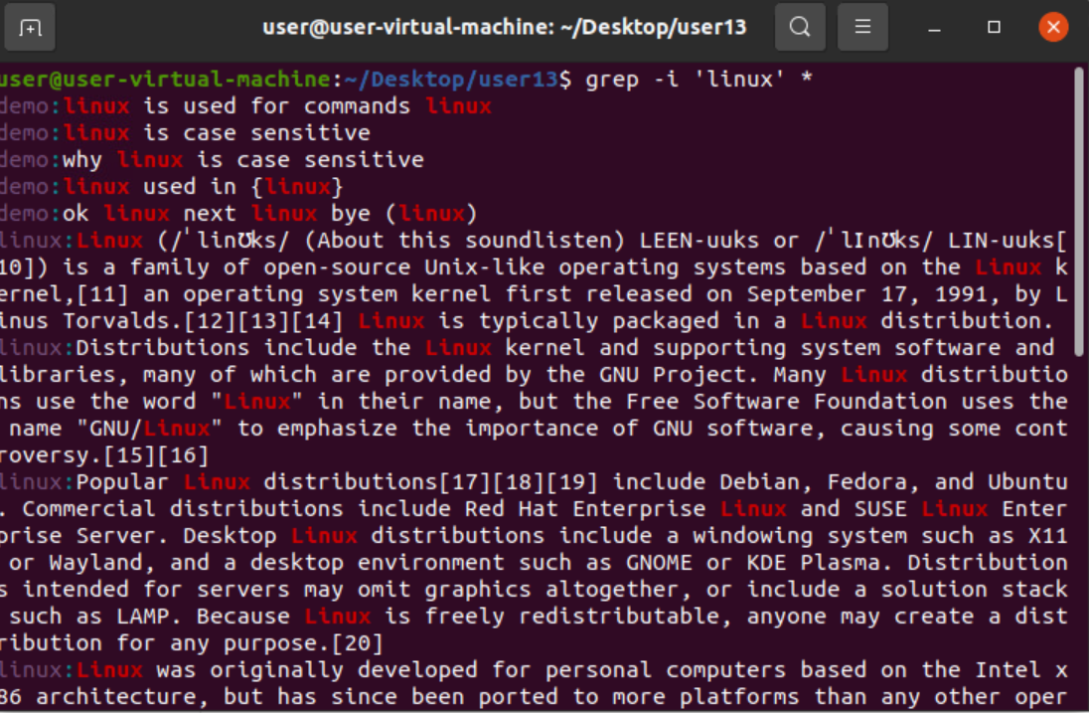

>7

>grep -c ‘ ‘ fname – gives count of character in lines.

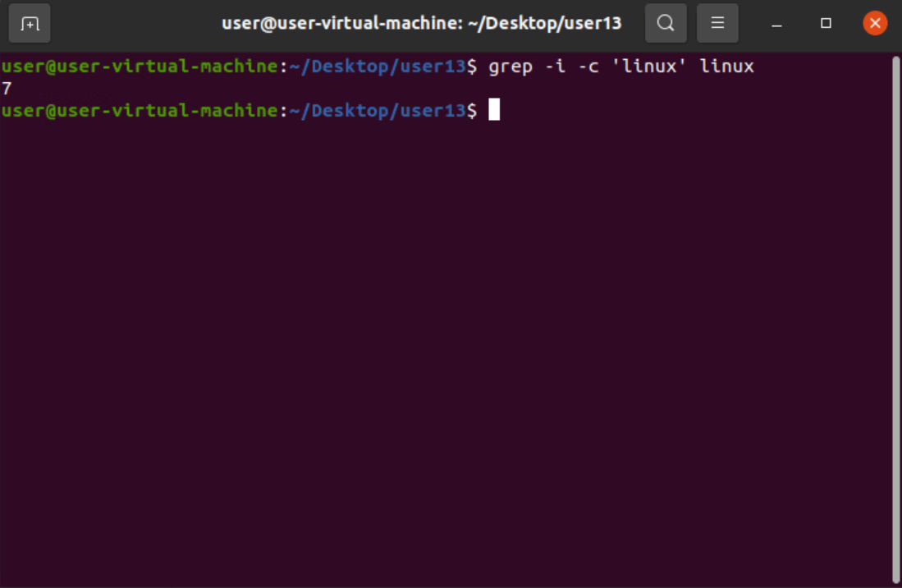

>8

>grep -c ‘’ \* - in all files.

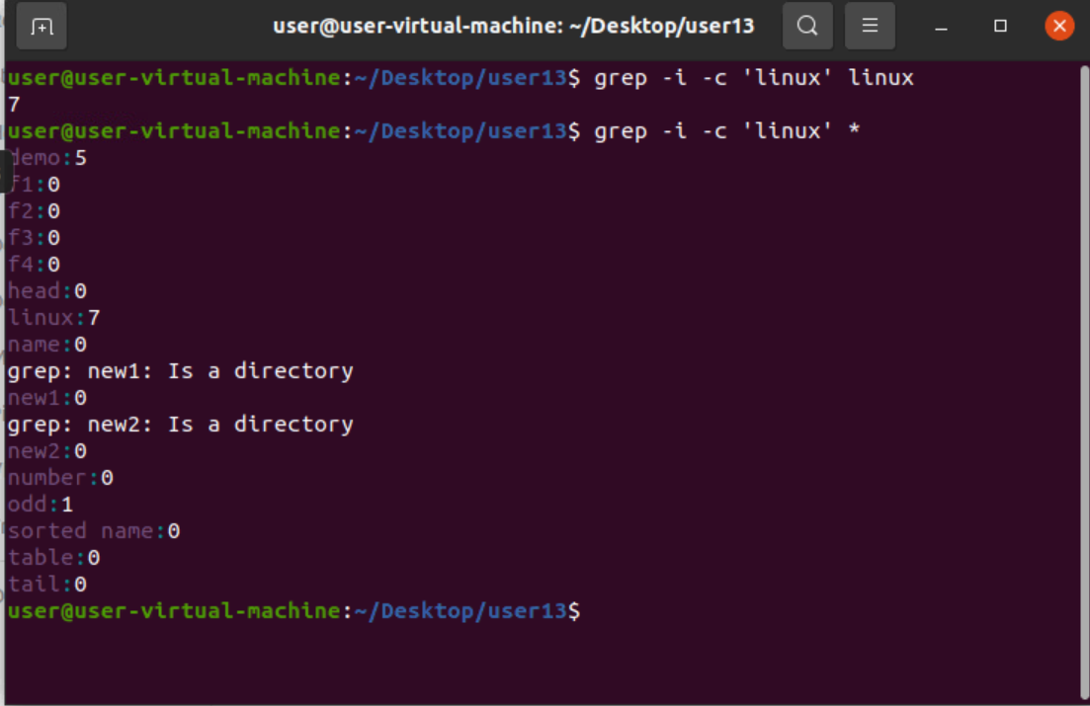

>9

>grep -l fname – lists file with word present.

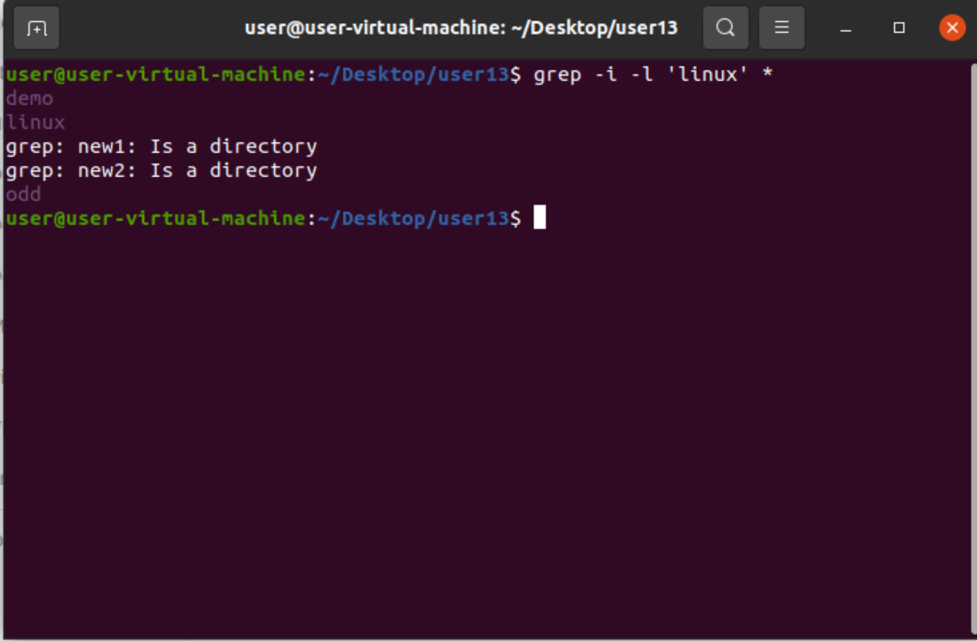

>10

>grep -I -o ‘ ‘ fname – gives output of words in lines only.

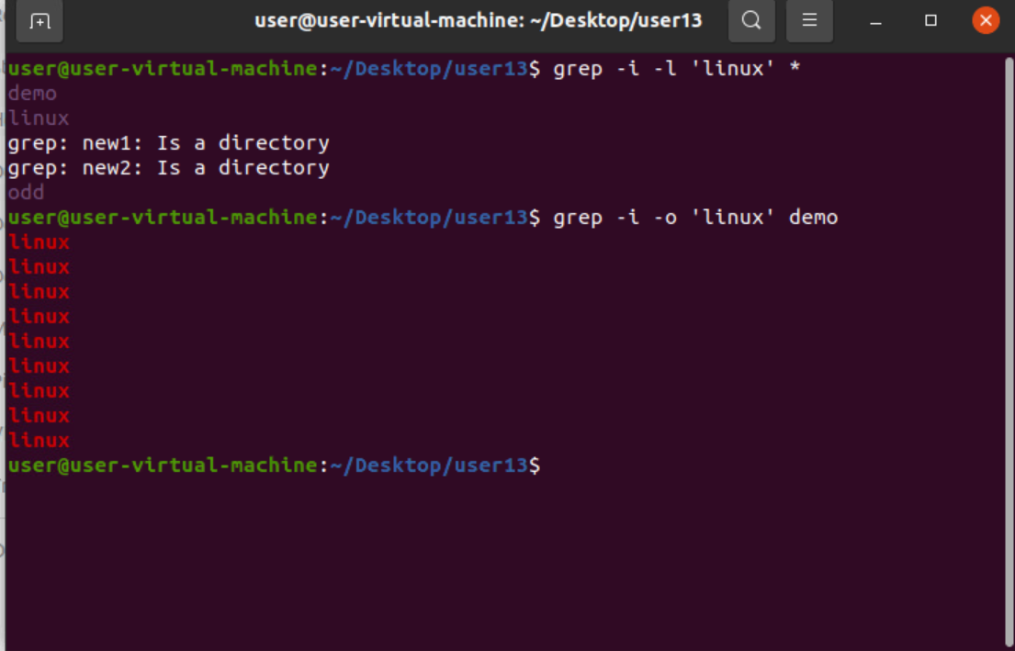

>11

>grep -I -n ‘ ‘ fname – display number of lines.

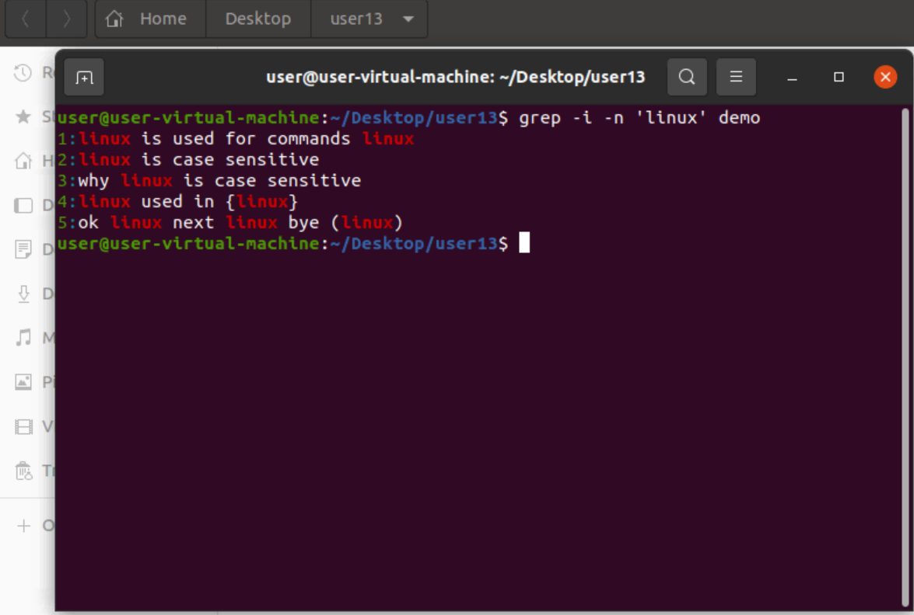

>12

>grep -I -v ‘ ‘ fname – gives lines without specified word.

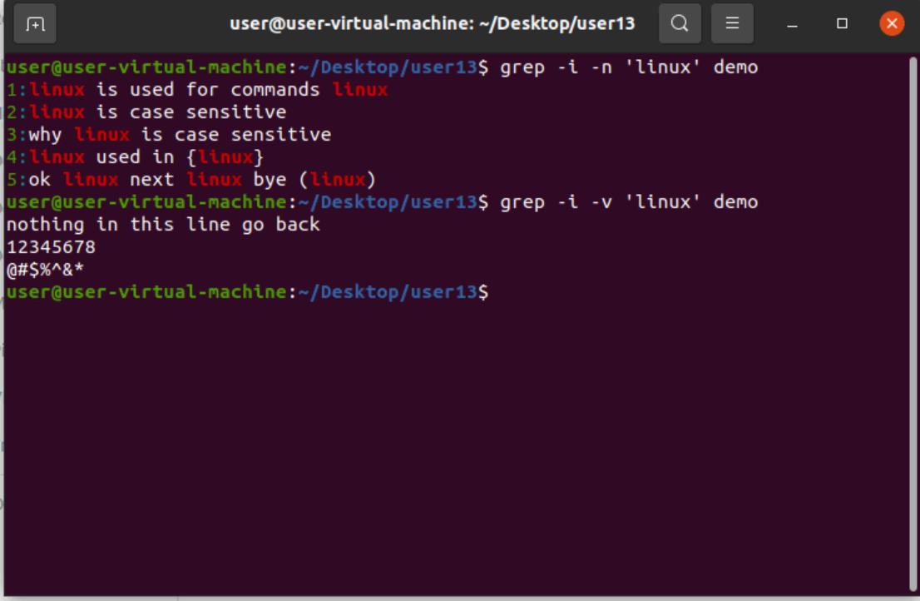

>13

>grep ‘^’ fname – gives lines starting with specified word.

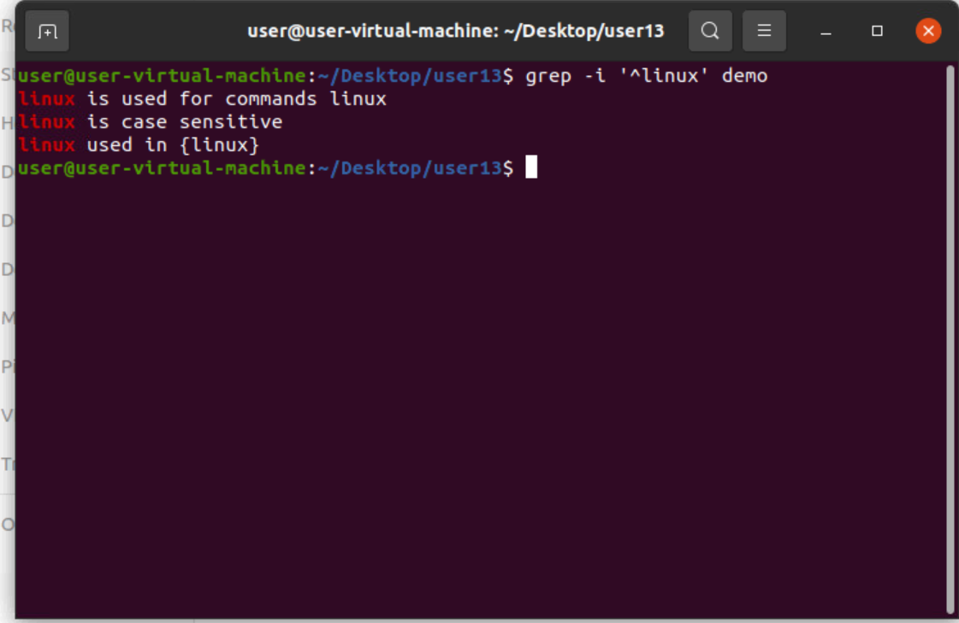

>14

>grep -I ‘$’ - gives lines ending with specified word.

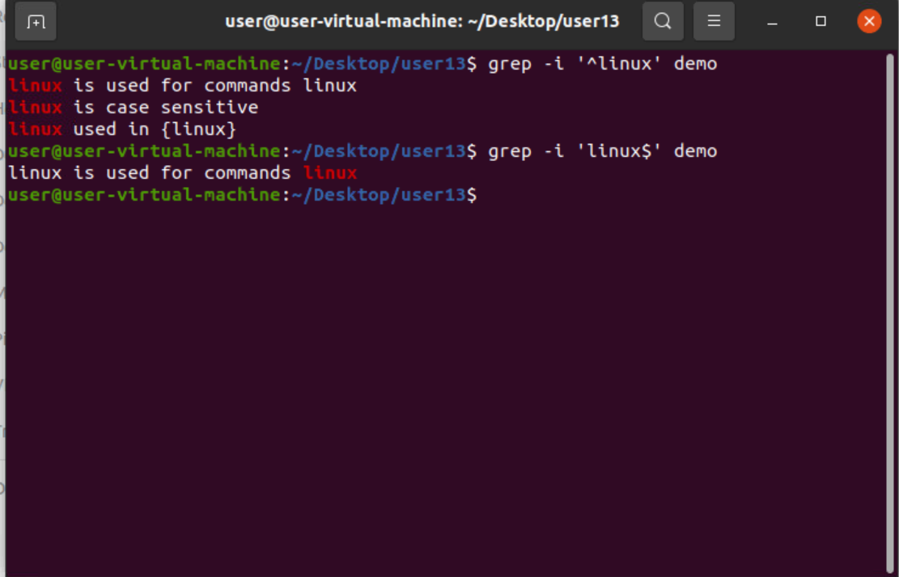

>15

>grep -I -An ‘ ‘ fname – prints after lines after specified word found.

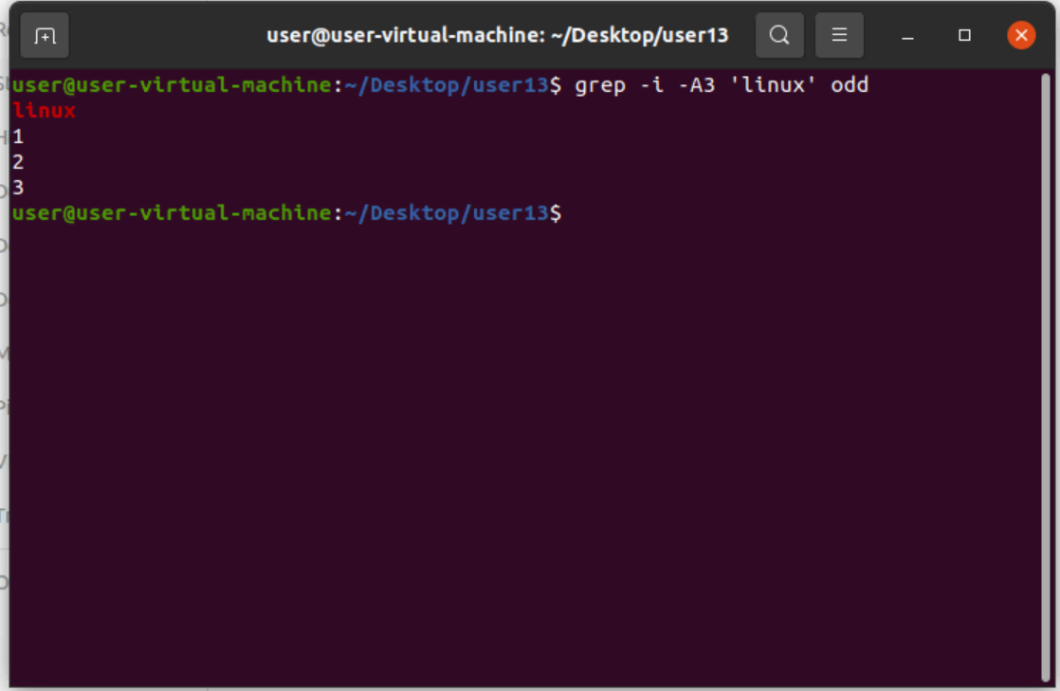

>16

> grep -I -Bn ‘ ‘ fname - prints before lines after specified word found.

>17

> grep -I -Cn ‘ ‘ fname - prints before and after lines after specified word found.

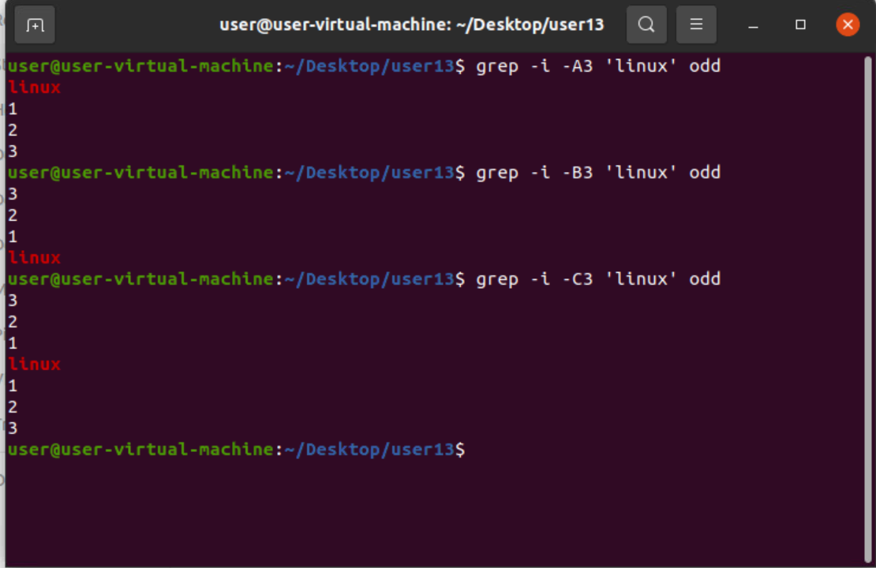

>18

>cat fname | tr ‘[a-z]’ ‘[A-Z]’ – converts all data into uppercase.

>19

>cat fname | tr ‘[A-Z]’ ‘[a-z]’ – converts all data into lowercase.

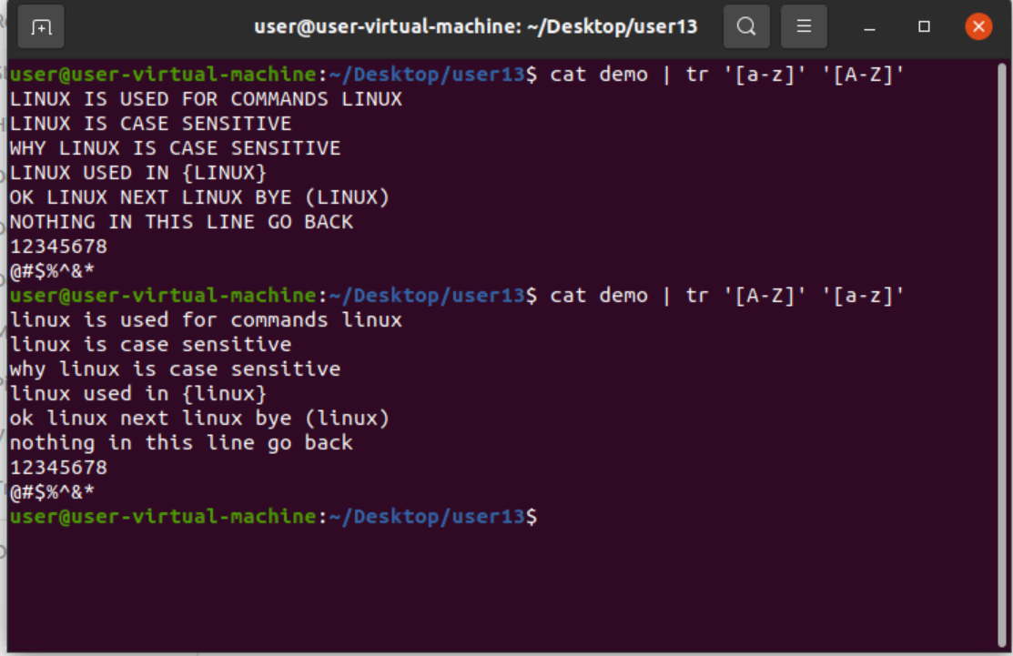

>20

> cat fname | tr ‘[:lower:]’ ‘[:upper:]’ – converts all data into uppercase.

>21

>cat fname | tr ‘[:upper:]’ ‘[:lower:]’ – converts all data into lowercase.

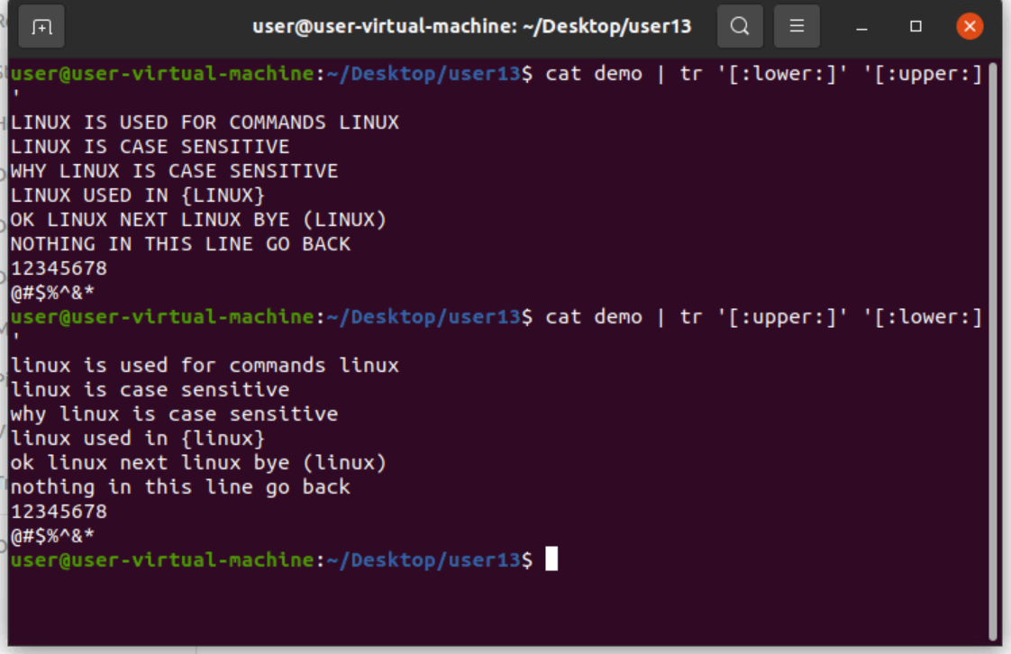

>22

>echo “hello world” | tr ‘[:lower:]’ ‘[:upper:]’ – coverts to uppercase.

>23

>echo “hello world” | tr ‘[:upper:]’ ‘[:lower:]’ – converts to lowercase.

>24

> echo “hello world” | tr ‘[a-z]’ ‘[A-Z]’ – coverts to uppercase.

>25

>echo “hello world” | tr ‘[A-Z]’ ‘[a-z]’ – converts to lowercase.

